[Title Should not be more than Fifty Characters]
  - [Author-1¹, Author-2^{1,2}, Author-3^{2,3}]
  - [¹Affiliation-A]
  - [²Affiliation-B]
  - [³Affiliation-C]
[Abstract content should not be more than 1000 words and should be the same as the text submitted in ConfTool. The abstract should clarify the research question, the research performed and methods applied, results and findings, as well as the inferences and conclusions of the authors. The text can be supplemented by two 300 dpi figures with separate captions. The figures should not take up more than one extra page combined, i.e., page 2. References should be on page 3. The camera-ready version should not take up more than 3 pages.]

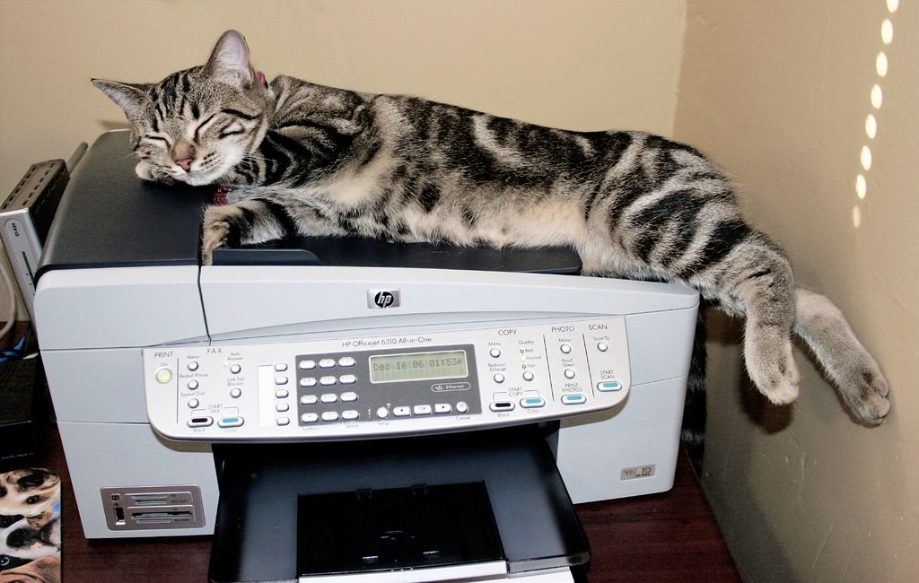
Figure 1. Results of a CAT scan for resting state of a participant in supine position; Image: https://live.staticflickr.com/136/324448467_3a65bc1c0e_b.jpg. Creative Commons.]

References:
[References do not count towards the total word count and should be in the style of Frontiers Journals, see https://www.frontiersin.org/files/pdf/Frontiers_Reference_styles.pdf]

